MYP4: Training Exercises Criterion A
Weight, Mass and Gravity:
4. What is the unit of weight? Circle the correct answer.
a) Newton (N) b) gram (g) c) atomic mass unit (amu) d) weight is unitless

5. The gravitational field strength of the dwarf planet Pluto is 0.063 times that of Earth.
- If a human of 50kg mass was standing on Pluto’s surface, what would their weight be? Show your calculations.

- Unlike Pluto, Mars is an actual planet. It is much larger than Pluto and has a higher mass. How do you expect the weight of the human to change if they were to travel from Pluto to Mars? The weight on Mars would be…
  - The same b. higher c. you don’t have weight on Mars d. lower

6. The asteroid Ceres is the biggest object in the asteroid belt between Mars and Jupiter. It has a gravitational field strength (g) of 0.28 N/kg at its surface.
- If an astronaut with a mass of 60kg would visit Ceres and land on the surface, what would their weight be? Show your calculations!

- How many times heavier would they be on Earth (g = 9.8N/kg)?

7. The earth (m₁=5.972*10²⁴kg) and the sun (m₂=1.989*10³⁰kg) orbit around each other (r=1.49*10¹¹m), and thus exert a gravitational force on each other. Calculate that please (Fg) :D

Remember: earth radius = 6’137’000m
8. There is an unknown asteroid at 2.3*10³m from earth’s surface. The gravitational force between the earth and the asteroid is 2394N. Calculate the mass of the asteroid! optional question!

Fundamental Particles & Forces:
9. Which fundamental particle is responsible for the electromagnetic force? Circle the correct answer.
- Graviton b. Neutron c. Photon d. Gluon

10. Circle the fundamental particles:
Proton Electron Up-Quark Atom Neutron Gluon W-Boson Photon

11. Which particles make up the nucleus of an atom?

12. If a particle would have three up-quarks and no down-quarks (no such particle exists!), what would its total charge be? Show your calculations!

13: Using arrows, match the correct force with its force-carrying particles.

Electromagnetic Force Gluon

Strong Interaction Z- and W-Bosons

Weak Interaction Graviton

Gravitational Force Photon

Molar mass conversions

14: Using the molar mass of the elements from your periodic table (next page), convert the following:
- 3 mol of nitrogen into g.

- 44g of carbon in mol

- 12g of copper in mol

- 4 mol of hydrogen in number of particles

- 0.6 kg of iron in mol

- 120 mmol of mercury in g

15: A water molecule (H₂O) consists of two hydrogen atoms and one oxygen atom. What is the molar mass of the H₂O molecule?

16: What is the molar mass of a Carbon Dioxide molecule (CO₂)?

17: Explain why the molar mass (relative atomic mass) of elements in the periodic table is not a whole number, despite protons and neutrons each having a mass of 1 g/mol.

Atoms and Electron Configuration:
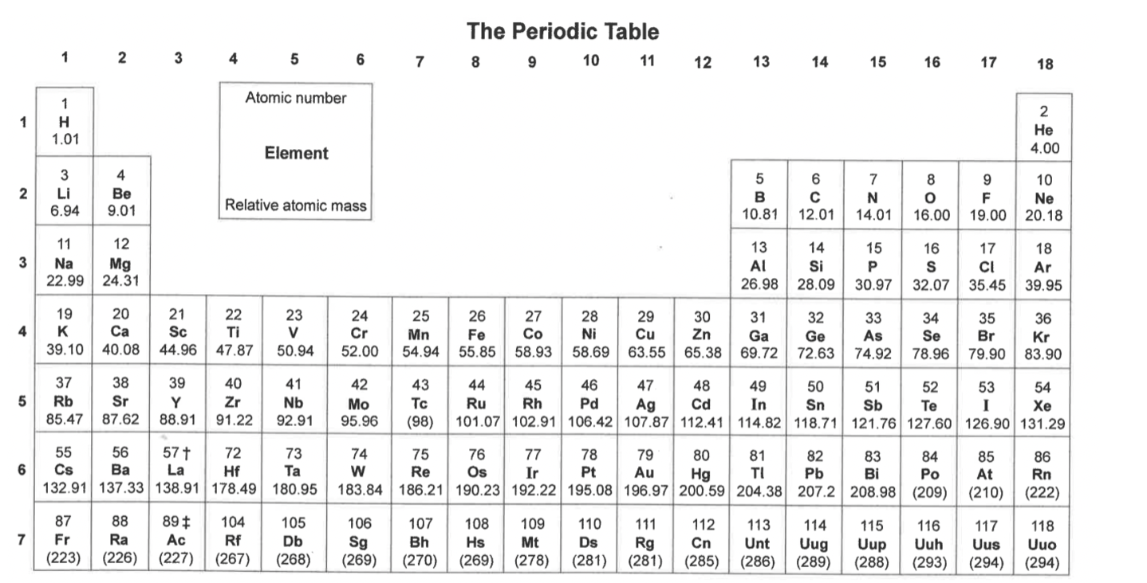
18. What is the electron configuration of (uncharged) Argon (Ar)? Also show the arrangement of electrons in the different shells around the nucleus in a schematic drawing!

19. How many electrons are in the valence shells of the following atoms?
- Aluminium (Al)
- Lithium (Li)
- Phosphorus (P)
- Selenium (Se)
- Rubidium (Rb)
- Neon (Ne)
20. What happens when we add a proton to the nucleus of a Sodium (Na) atom? Describe its changes in identity, charge, and mass.

Scales and Units:
1. Convert the sizes of these objects into meters:
a) HIV virus: 90 nm
b) Grand Canyon: 450 km
c) X-Chromosome: 4 μm
d) Hydrogen atom: 0.31 nm
e) Distance from Earth to Moon: 380.000 km
f) Milky Way galaxy: 120.000 light years (bonus question!)

2. Convert the masses of these objects into grams:
a) Blue whale (adult female): 15 Mg
b) Giraffe (average adult): 1.192 kg
c) E. coli bacterium: 3.3 μg
d) Human egg cell: 2 ng
e) Uranium atom: 238 amu (bonus question! You need to google for this one)

3. Sort these objects from large to small: Basketball, the Sun, plant cell, X-chromosome, Helium nucleus, down quark, distance Earth – Moon, leaf vein, proton

Bonus: The nucleus of a eukaryotic cell and the nucleus of an atom (e.g. Carbon) are both referred to as “nucleus”. Yet they are different objects! The size of a cellular nucleus is ~7 micrometers. The size of a carbon atom nucleus is ~6*10⁻¹⁵m.
- Which object is larger? The nucleus of the atom, or the nucleus of the cell? How many times larger? Show your calculations!

